# Numbering Olympic games in descending order

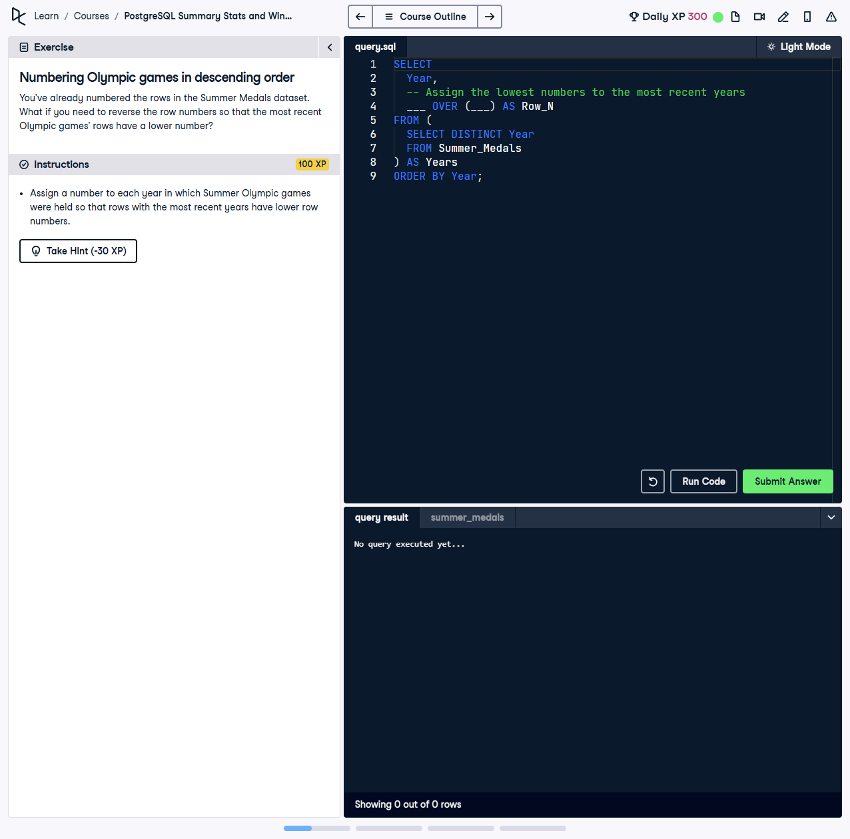

You’ve already numbered the rows in the Summer Medals dataset. What if you need to reverse the row numbers so that the most recent Olympic games' rows have a lower number?

This exercise involves assigning a number to each year in which Summer Olympic games were held, but reversing the numbering so that the most recent years have the lowest numbers.

## Correct Answer

SELECT  
 Year,  
 ROW_NUMBER() OVER (ORDER BY Year DESC) AS Row_N  
FROM (  
 SELECT DISTINCT Year  
 FROM Summer_Medals  
 ORDER BY Year ASC  
) AS Years  
ORDER BY Year DESC;

Explanation of the query:

1. `SELECT DISTINCT Year FROM Summer_Medals`: Retrieves unique years from the dataset where Summer Olympics were held.

2. `ROW_NUMBER() OVER (ORDER BY Year DESC) AS Row_N`: Assigns a sequential number to each year, but in descending order of years.

3. Subquery `AS Years`: Ensures the dataset contains distinct and ordered years before assigning row numbers.

4. `ORDER BY Year DESC`: Ensures the final result is sorted by year in descending order, matching the reversed numbering.